HTML Style Element

📘 Definition
# Source: AI Source: Provided by: [Data Path: Persons Table -> ID Column: 1, Name_En Column: Motasem Essam] -> From: [ChatGPT] on [5/6/2026]
The HTML <style> element is used to define CSS (Cascading Style Sheets) directly inside an HTML document to control how elements look on the webpage.

🧠 Simple idea
# Source: AI Source: Provided by: [Data Path: Persons Table -> ID Column: 1, Name_En Column: Motasem Essam] -> From: [ChatGPT] on [5/6/2026]
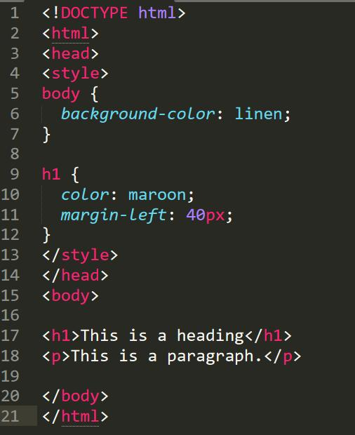
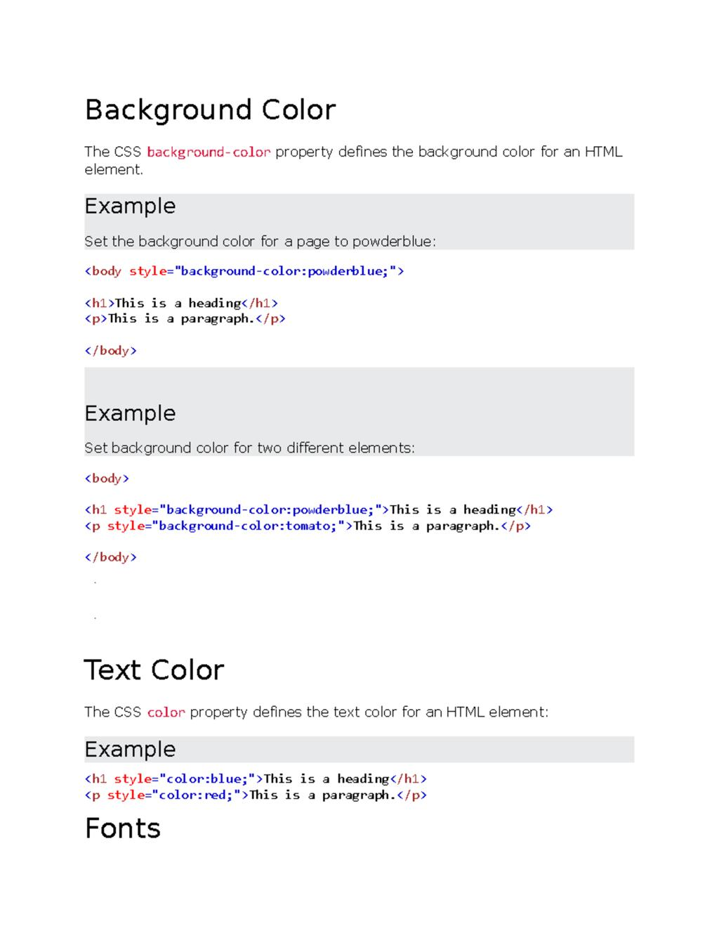
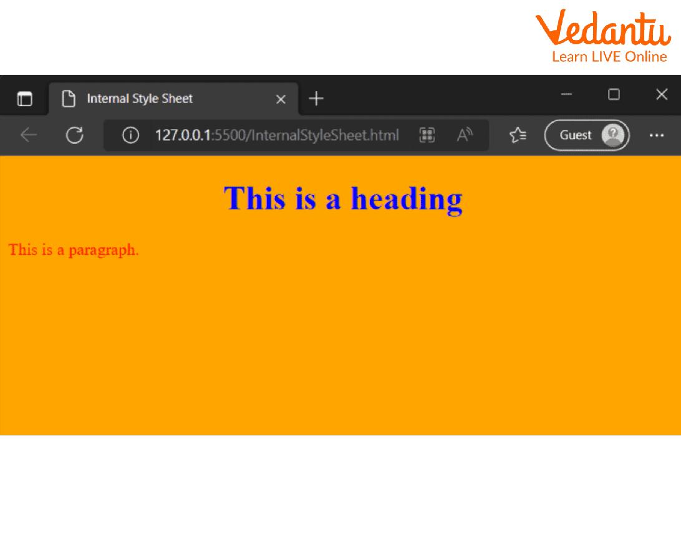
- It is used to design and decorate the webpage
- It changes things like color, font, size, spacing, layout

💻 Example

Full Example
# Source: AI Source: Provided by: [Data Path: Persons Table -> ID Column: 1, Name_En Column: Motasem Essam] -> From: [ChatGPT] on [5/6/2026]
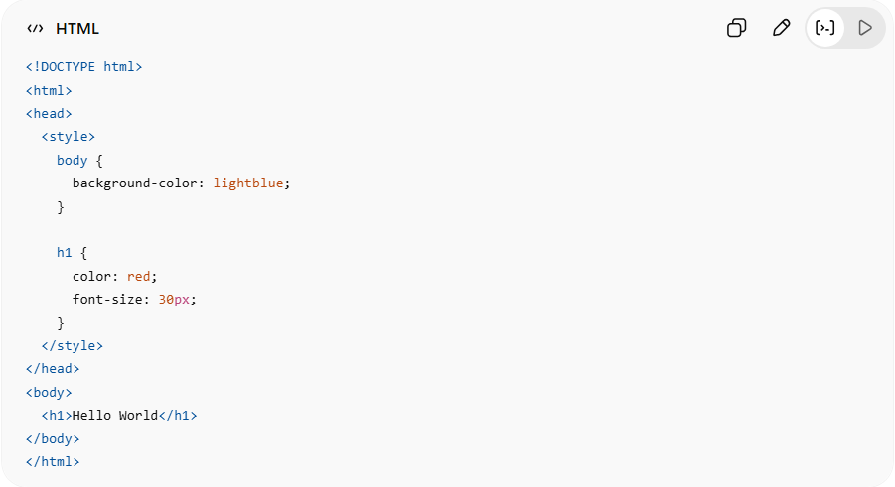
<!DOCTYPE html>
<html>
<head>
<style>
body {
background-color: lightblue;
}
h1 {
color: red;
font-size: 30px;
}
</style>
</head>
<body>
<h1>Hello World</h1>
</body>
</html>

Real Example
# Source: ScreenShot Source: Provided by: [Persons Table -> ID Column: 1, Name_En Column: Motasem Essam] -> Tool: [Automation Table -> ID Column: 16, Name_En Column: Screen Capture] -> From [Operating System: Windows] on [5/6/2026]
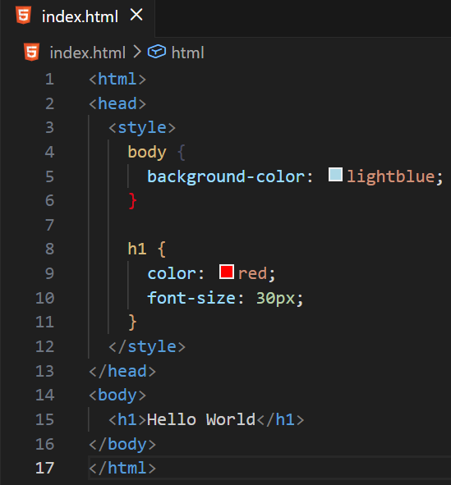
<html>
<head>
<style>
body {
background-color: lightblue;
}

h1 {
color: red;
font-size: 30px;
}
</style>
</head>
<body>
<h1>Hello World</h1>
</body>
</html>
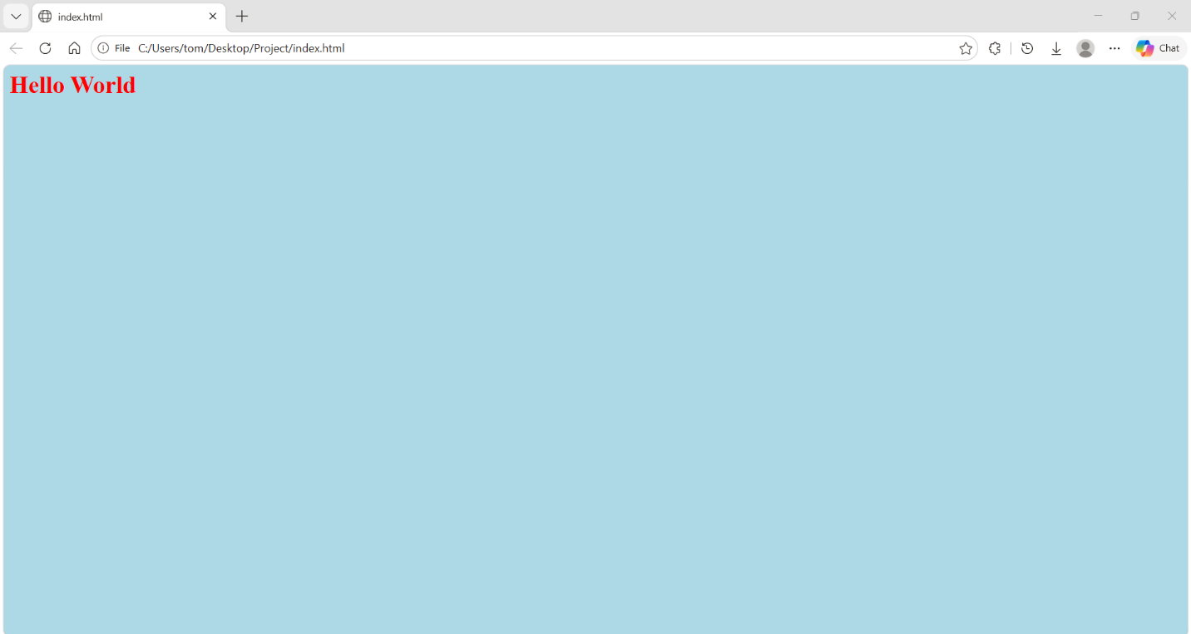

⚙️ Where it is used
# Source: AI Source: Provided by: [Data Path: Persons Table -> ID Column: 1, Name_En Column: Motasem Essam] -> From: [ChatGPT] on [5/6/2026]
- Inside the <head> element
- For internal CSS styling
- When you don’t want to use an external CSS file

🚀 In short:
# Source: AI Source: Provided by: [Data Path: Persons Table -> ID Column: 1, Name_En Column: Motasem Essam] -> From: [ChatGPT] on [5/6/2026]
The <style> element is used to add CSS inside an HTML page to style and design the webpage.

